**Brooklyn torah gazette**

**For parshas Terumah 5780**

Volume 4, Issue 25 (Whole Number 177) 4 Adar 5780/ February 29, 2020

**Printed L’illuy nishmas Nechama bas R’ Noach, a”h**

**The Connection of Adam Harishon to Dovid Hamelech**

**By Daniel Keren**

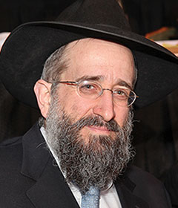

One of the featured speakers at the recent Martin Luther King Jr. Legal Day Hakhel Yarchei Kallah was Rabbi Yisroel Reisman, the Mora D’asra the Agudath Israel of Madison who continued with his series of legal holidays lectures on Sefer Divrei Hayomim (the Book of Chronicles). The topic of his most recent shiur was “The Song of Dovid Hamelech.”

Rabbi Reisman said that the ikker (main point) of Divrei Hayomim is that it tells the story of Moshiach or the progression of Olam Hazeh (this world). According to a Midrash, Adam Harishon (the first man) was shown a vision of all of his future descendants.

And he saw that the holy Dovid Hamelech (King David) was only destined to live but three hours in Olam Hazeh. When he questioned the Ribono shel Olam (Master of the World) why this great neshama (soul) would only live such a short period of time, He was not answered. Adam then asked if he could give any of his years to Dovid and the Ribono shel Olam answered affirmatively. He then asked to donate 70 years from his life and that is why he didn’t live the full day or 1000 years of life destined for him originally, but died at the age of 930.

Rabbi Reisman also noted another version from the Zohar which said that Yaakov and Yosef together donated 70 years of their life to Dovid. Either way, if the gift of life came from Adam Harishon or Yaakov and Yosef, this poses a riddle that we can’t easily understand.

**One’s Own Life Takes Precedence**

We have a rule or halacha (law in Judaism) that kodem hayecha, one’s life takes precedence over that of another person. If you are in a desert with somebody else and you have only water that is sufficient for one person to survive until you get to a place where more water can be found, halacha requires you to drink that water (even if the other person is a greater Torah scholar than you and is more valuable to Klal Yisroel at large.)

According to the opinion that Adam Harishon gave up 70 years of his life to Dovid Hamelech, Rabbi Reisman said that would explain why the Book of Chronicles which was written by Ezra begins with the account of the chronicles of Adam, the first man.

Had Adam Harishon not sinned by eating the eitz hadas (the forbidden fruit of the tree of knowledge of good and bad), the world would not have been so seriously flawed spiritually and there would never have been a subsequent need for a Moshiach (redeemer) to make a tikun (spiritual repair) for the geula (redemption) that we all pray for three times a day.

Moshiach is a tikun for the spiritual imperfections of Olam Hazeh and that was the role Adam after his sin saw in the neshama of Dovid who was however only destined to live but three hours. That is why Adam Harishon was inspired to ask G-d to allow him to donate 70 years from his life to that precious neshama. Indeed Adam saw in Dovid Hamelech the tikun for his own failure with the eitz hadaas.

**No Need for a Moshiach Until the Sin of the Eitz Hadaas**

As mentioned before until Adam sinned with the eitz hadaas, there was no need for a Dovid Hamelech (and his potential to be a progenitor of the Moshiach) to even exist. But once Adam stumbled, this world became seriously flawed and was in great need for a tikun that could only be achieved by the coming of Moshiach, a descendant of King David and therefore Adam Harishon saw in his donating precious years from his life an opportunity to be a part of making that tikun and redemption possible.

Similarly Rabbi Reisman said that we learn of the severe punishment suffered by the descendants of Eli Hakohen. For generations going into many centuries after the downfall of Eli Hakohen and his sons, all of the male descendants of the family of Eli Hakohen died young. This is discussed in the Talmudic Tractate Yevamos where Rabba and Abaya, two descendants of Eli Hakohen argued whether the merit of Torah study or the performance of good deeds to add life to someone who would otherwise be cursed with an early death.

Rabbi Reisman asked what was the nature of the family sin that continued to punish members centuries later. He explained that the sons of Eli Hakohen had corrupted the service of the kohanim (the priesthood) and their father had not stopped them from making the offerings that people came to bring into a highly profitable family business. This resulted in a terrible chilul Hashem (desecration of G-d’s Name) that could only be atoned by the early death of the male descendants since it made all of Klal Yisroel realize just how serious and terrible it was to commit a chilul Hashem.

Rabbi Reisman said that until just recently in 1993, the secular historians did not believe that Dovid Hamelech really existed and was a legitimate historical figure. Up until then, historians dismissed him as a merely mythical personality such as King Arthur of Camelot.

**The Exciting Archaeological Discovery at Tel Dan**

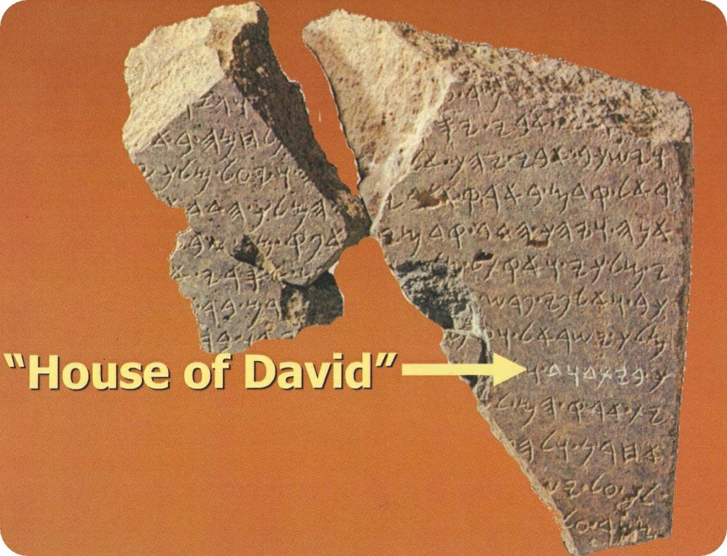

**Photo of the exciting Tel Dan aracheological discovery of 1993**

Then in 1993 during an archaeological expedition at the site of Tel Dan in northern Israel, an excavation directed by the secular Israeli archaeologist Avraham Biran found a stone slab (stele) that cause much excitement and furnished the first “historical” evidence of a King David from the Bible. Written in the Aramaic characters it told of the victory of an Aramaen king who bragged that he had defeated the king of Israel and also the king of the House of David.

Rabbi Reisman said that as frum Jews we should not be impressed by the excitement of the secular archaeologists. Why is the Tel Dan find more compelling to our belief in the existence of Dovid Hamelech that the accounts we can read in Sefer Shmuel?

King David had a very difficult life. His father suspected him to be a mamzer, illegitimate. After he killed Golias (Goliath), his father-in-law Shaul Hamelech (King Saul) feared his son-in-law was seeking the throne and tried to kill Dovid. And even after he became king he had terrible tragedies with some of his sons.

And it is because of a life overflowing with difficult challenges that he became great and devoted himself to loyally serving Hashem. It was during these harsh chapters of his life that Dovid composed his spiritually beautiful chapters of Tehillim (Psalms) that continue to give comfort to much of the world today when others find themselves plagued by times of trouble.

In Divrei Hayomim, we find, Rabbi Reisman said, something that we don’t see in Sefer Shmuel. In the last ten years of his life, Dovid suffered from terrible pain. One of his sons (Adoniyah) while David was still alive declared himself to be king and this caused Dovid to publicly crown his son Shlomo (Solomon) king during his lifetime.

**A Lesson for all Jews from Dovid Hamelech**

After this Dovid regained his strength that he had lost during his previous 10 years of great physical pain and devoted himself to writing down the full plans for the construction of the Beis Hamikdosh (the Holy Temple in Jerusalem) that would be carried out by his son Shlomo Hamelech.

This is an important example, Rabbi Reisman said for Klal Yisroel in Golus (our exile when we are not in control of Eretz Yisroel, the Land of Israel). When life is difficult, one has to pick oneself up and rededicate himself to the service of the Ribono shel Olam. This is especially true when everyone else around you is down and emotionally defeated.

Reprinted from the January 30, 2020 edition of The Flatbush Jewish Journal.

**Rav Avigdor Miller On**

**Speaking Out Your Worries**

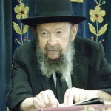

**QUESTION:** Doesn’t it say in the *Gemara*, דאגה בלב איש ישחנה לאחרים – that if a man has some worry in his heart, he speak it out to others? So why did you say before that by complaining you make things worse?

**ANSWER:** There’s a big difference between complaining and speaking to other people. If you’ll complain to other people, all you’re doing is putting a load on that person too. If you’ll tell them, “I had a bad day today. It was dark and rainy and everything I tried didn’t work out,” so all you’re doing is making that person also lose heart. You’re dispiriting him.

But if there’s some problem that’s pressing on you – not a complaint, not a matter of being dissatisfied – but there’s a problem, and you discuss the problem with somebody else, somebody who is capable, then that person might point out to you ways and means that will help you easily solve or dodge that problem. That’s what it means.

Now, the truth is that even if you complain to somebody else, it could be that he could turn around your words and change your thoughts so that you should stop complaining, but the *ma’amer* דאגה בלב איש doesn’t refer to that. It’s not talking about complaining – it refers to problems that you have.

Now that’s an important point. Many people go around laden down with worries, loaded down with problems which really are nothing. They make mountains out of molehills and someone has to guide them.

Here’s a problem for instance: “My mother-in-law said this and this to me!” And the daughter-in-law is boiling now – she’d like to murder her mother-in-law. She can’t rest! Actually, it’s nothing at all. The mother-in-law wasn’t thinking – she had no brains anyhow; she wasn’t thinking what she said. The next minute she forgot what she said. But the daughter-in-law has no brains either and therefore she took the words to heart and now she’s boiling with indignation and it ruins her life. A lot of people are like that.

But if she’ll go to somebody – somebody wise – and she asks, “What should I do with my mother-in-law? She’s a big problem!” so that wise person says, “What did your mother-in-law do to you? Did she tell her son to divorce you?”

“No, no.”

“What did she do?”

“She said something about my cooking.”

“So what?! What about it?!”

ישחנה means that you should speak it out with somebody else and that person may show you a different perspective and you’ll see that it’s nothing at all. Or there are other ways, other advice he might give you. “If your mother-in-law is calling you up on the telephone and breaking your heart with her complaints, see that the telephone is always off the hook so she gets a busy signal.” Whatever it is, another person can give you advice.

*Reprinted from the February 11, 2020 email of Toras Avigdor adapted from Tape #503 (April 1984).*

**The Shmuz onParshas Trumah**

**Hishtadlus – For**

**A Dvar Mitzvah**

**By Rabbi Bentzion Shafier**

**Founder of TheSmuz.com**

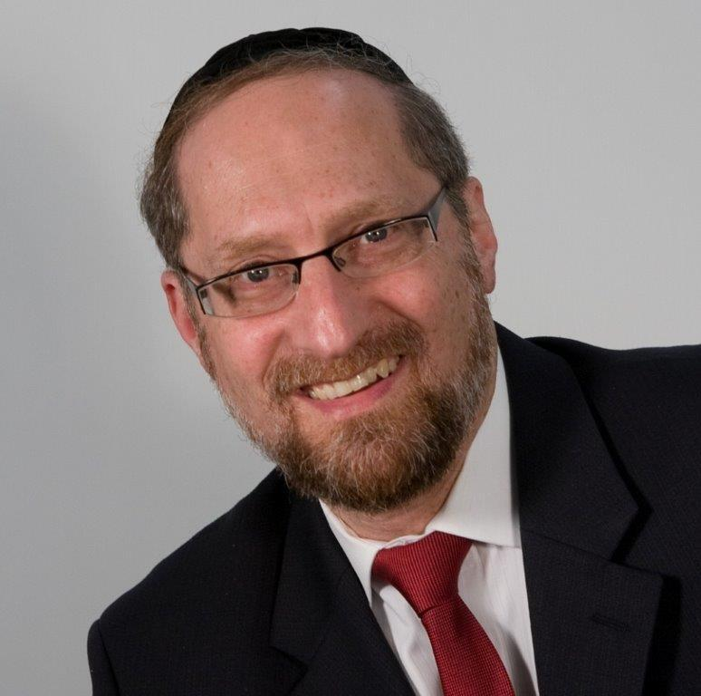

*“And you shall make a menorah of pure gold, hammered out shall the menorah be made. Its base, its shaft, it cups, its knobs, and its blossoms shall be (hammered) from it*.” — Shemos 25:21

Moshe Rabbeinu was charged with the construction of the *Mishka*n, the dwelling place of HASHEM in this world. While the components of the structure are physically complex, the *kavannas* — the specific intentions required during the process of building it — are even more intricate.

The most complicated of all of the vessels was the *menorah*. Its design was so elaborate that even after HASHEM taught Moshe how it was to be built, Moshe still didn’t understand its unique nature and was unable to form it. Therefore, HASHEM showed Moshe an image of a *menorah* made of fire so that Moshe could actually see the finished form and imitate it.

Yet Rashi tells us that when it came time for the construction of the *menorah*, Moshe still could not fathom its structure and was unable to fabricate it. HASHEM said, “Throw the clump of gold into the fire, and it will form by itself.” This is how the *menorah* was created — on its own.

This Rashi is perplexing. Since the *menorah* was so intricate that Moshe could not understand its inner nature and how to form it, then why did HASHEM bother to show him the image of the *menorah* in fire? HASHEM knew that Moshe wasn’t going to be able to create the *menorah* himself. He knew that in the end it would have to come about by Moshe’s throwing the clump of gold into the fire. Why did HASHEM show Moshe the image of the *menorah* so that he should understand how it was to be formed? Clearly, creating the *menorah* was beyond human capacity. Why did Moshe need to have a clear image of what it was to look like?

**Balance of Bitachon and Hishtadlus**

The answer to this question is predicated on understanding the balance between HASHEM’s involvement in the running of the world and man’s obligation to put in his effort — the balance between *bitachon* and *hishtadlus*.

One of the basic facts of life is that HASHEM runs this world. While it may appear that man is in charge, HASHEM orchestrates every activity on the planet. The question is: what is man’s part? If HASHEM determines all outcomes, how is man supposed to act? What is his role?

**How Much Effort Should I Put In?**

The *Chovos Ha’Levovos* teaches us that we are obligated to act *b’derech hatevah* – in the **ways of the world**. In other words, we are obligated to go through the motions as if the results are dependent upon us, knowing all the while that the outcome is completely out of our hands.

We work for a living, knowing that the amount of money we are to make has been set on Rosh Hashanah. We go to doctors when we are sick, even though we know that our health is determined solely by HASHEM. We put in our **effort**, knowing all the while that it is HASHEM’s world and that He alone determines the **outcome**.

Amazingly, whenever we accomplish something in this world, the results are credited to us even though we are fully aware that HASHEM was One Who did it all. We merely went through the motions. When we use that system, it is considered as if we did the action.

**Answer: Why Moshe Needed to**

**See the Image of the Menorah**

**This seems to be the answer to the question on Rashi. HASHEM wanted the** *Mishkan* and its vessels to be constructed by man. However, it was impossible for man to make them. Even the greatest of men couldn’t comprehend how to make a *menorah*. So his *effort* was to do all that he could and then rely on HASHEM for the rest. Moshe would put the gold into the fire, and the *menorah* would form on its own. Moshe used the system that HASHEM created to bring forth the *menorah*.

However, for the creation of the *menorah* to be credited to man, Moshe had to at least have a vision of what it was that he was creating. Once he had that concept in mind, throwing the clump of gold into the fire was considered as if he made the *menorah* himself. It was then considered as if he used HASHEM’s system to bring about this result.

If Moshe didn’t have a clear vision of what it was that he was creating, then in no sense could it be considered something he made — it would have been the fire that made it. Once he knew what it was that he was setting out to make, he then **harnessed a force** that HASHEM created to bring about that result. In this case, the force was the fire bringing about the *menorah*.

**Bitachon in Our Lives**

This concept has great relevance to us as there are many situations in which we reach a point where there is no clear path to follow. Whether it be deciding from two almost identical career choices, determining which medical “expert” to listen to, or deciding which school to enroll our children in, we are obligated to be responsible, use our best judgment, and determine according to the ways of the world what is the best approach. Once we have reached that point, we “throw our clumpof gold intothe fire*.*” We rely on HASHEM to bring about the results that He has predetermined to be the best for us.

*Reprinted from this week’s website on TheShmuz.com This is an excerpt from the [Shmuz on the Parsha book](https://theshmuz.com/product/shmuz-on-the-parsha-book/).*

**Jacob’s Cedar Trees and Its Secret Lesson of Nechama**

**From the Talks of the Lubavitcher Rebbe**

**Rabbi Menachem Mendel Schneerson, Zt”l**

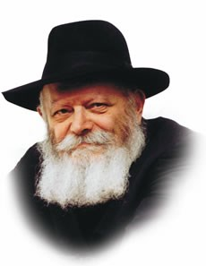

This week's Torah portion, Teruma, details the various components that went into the Mishkan -- the portable Sanctuary erected by the Jews during their journey through the wilderness.

The Sanctuary itself was built of tremendous planks of acacia wood, the dimensions of which were "ten cubits the length of the board, and one-and-a-half cubits the width of each board."

An obvious question is asked: Where did the Children of Israel find such a huge amount of wood in the middle of the desert?

Rashi, the great Torah commentator, provides us with an answer taken from the Midrash Tanchuma: "Our Forefather Jacob perceived with his spirit of prophecy that the Jewish people would one day build a Sanctuary in the wilderness. He therefore brought cedars with him to Egypt and planted them, commanding his children to carry the trees with them when they later left Egypt."

This explanation is also in accord with another verse in the Torah which states that the donations of wood for the Sanctuary were made by "those who had acacia wood with them," implying that the wood belonged to the Children of Israel while they were yet in Egypt.

Indeed, more than two hundred years before the Jews were even subjugated, Jacob saw to it that his descendants would have a sufficient reserve of wood to build the Sanctuary.

But why was this so important? Couldn't they have purchased the wood from Egyptian merchants, or sent emissaries to the nearest forest to obtain the needed materials?

In truth, Jacob's actions held a deeper meaning than merely supplying his children with wood. Jacob's intent was to provide the Jewish people with succor and consolation that would enable them to survive the harshness of the exile.

G-d's promise to redeem them from Egypt was not enough; Jacob wanted his children to be comforted by the sight of the trees and reminded of the Sanctuary they would one day erect.

Additional solace was derived from the fact that Jacob had brought the saplings with him from the holy land of Israel, reminding the Jewish people of their origins as well as G-d's promise to bring them back to their land.

This consolation during the exile is also alluded to in the source for this explanation -- Midrash Tanchuma, as Tanchuma is word related to the Hebrew word for consolation and comfort -- "nechama."

A similar type of consolation has also been granted to us during our present exile, which, G-d willing, is about to come to an end. The "cedar trees" of our time are the tzadikim (righteous people) who exist in every generation, as it states in Psalms, "A righteous man will flourish like a date palm, like a cedar in the Lebanon he will grow tall."

These tzadikim, who are entirely above the constraints of exile, prevent the Jewish people from losing hope and awaken their hearts to the Redemption.

In this way, the Jewish people will merit the ultimate comfort and consolation in the literal sense, with the full and complete Redemption with Moshiach NOW!

*Reprinted from the Issue #354 of L’Chaim Weekly (Parashat Terumah 5755/1994)*

**Rabbi Berel Wein**

**On Parashas Terumah**

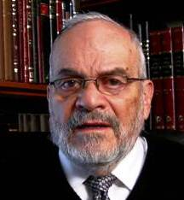

One of the greatest problems that has dogged religious life throughout the centuries is the place of material wealth and money in the structure of religious life. It is obvious to all that wealth corrupts and sullies noble programs and plans.,

The question boils down to the eternal issue as to whether the noble ends - Jewish education, synagogue worship, social charitable endeavors -- justify the means, as the process often borders on the unethical procurement of money.

Monetary scandals have plagued all religious projects and ambitions from time immemorial. The fact that the goal trying to be achieved is so noble and morally necessary, makes the temptation to deviate from correct probity and proper behavior in fund raising and monetary conduct all the more tempting. Unfortunately, the history of religion is littered with monetary scandals driven by poor decisions.

The prophets of Israel decried this situation during First Temple times, but apparently to little avail. Religion sadly has a tendency to transform itself into a business, a commercial enterprise. And this always leads to the desecration of G-d's name and catastrophic disasters. Many commentaries and scholars have stated that this monetary corruption was the real basis for the destruction of the Temples themselves, and the continued cessation of Temple service even until our very day.

Even buildings and programs conceived in holiness and founded by the most righteous of people are susceptible, over time, to fall into the trap of monetary scandal. I need not and will not enumerate specific examples of this weakness, but all of us are aware of their existence and sad influence.

Yet, despite all of this, these dangers are almost inevitable. This week's Torah reading combines the ideas of holy service to G-d with the necessity of fund raising and material wealth. The Torah apparently is of the opinion that the benefits of channeling and using money for noble good outweighs the dangers inherent in combining religion with wealth and money. In fact, this is the pattern of the Torah in all natters of everyday life, events and society.

Judaism does not allow for excess ascetic or hermit-like lifestyles. We are always somehow to be engaged in this world, tawdry and flawed as it may be. Yet the challenge is to somehow remain a holy people, a kingdom of priests, while dealing with these challenges that mark our daily lives and society.

The holy tabernacle/mishkan is to be constructed through heartfelt donations of material wealth and personal volunteerism. Though religion and faith are corrupted by monetary issues, wealth applied correctly and through a generous hand can enhance and even ennoble religion.

Moshe was shown a coin of fire in Heaven. It could burn and destroy, but it could also warm and light the way. The word Terumah itself, in its literal sense, means to uplift and raise. Wealth properly used and applied can be the engine that propels all holy endeavors forward. As it was in the time of Moshe, so, too, does it remain one of the greatest challenges in Jewish life.

*Reprinted from this week’s website of Rabbiwein.com*

**The Message of the Shulhan**

**By Rabbi Eli J. Mansour**

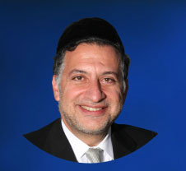

Parashat Teruma describes the Mishkan, the portable Bet Ha’mikdash which accompanied Beneh Yisrael as they traveled in the wilderness, and which would eventually be replaced by the permanent Bet Ha’mikdash.

Among the more surprising features of the Mishkan – and, later, of the Bet Ha’mikdash – is the Shulhan (table).  The Shulhan contained twelve loaves of bread, which were baked each week and then eaten by the Kohanim.  We might, at first glance, wonder what a table with bread would be doing in the Mishkan, the site of sanctity and of the divine presence.  Why does G-d want there to be bread in the holiest site in the world?

The answer is precisely that the ideal of Kedusha encompasses all aspects of life, including our physical pursuits. Unlike some other religions, Judaism does not view physical activity as inherently evil or impure. To the contrary, one of our main challenges and obligations as Torah Jews is to raise and elevate physical life.

We are not able or expected to live as angels. The Torah commands in last week’s Parasha, Parashat Mishpatim, “Ve’ansheh Kodesh Tihehun Li” – “You shall holy people to Me.”

The Rebbe of Kotzk commented that we are to first strive to be “Ansheh” – “people,” human beings – and only then strive for the level of “Kodesh.” We become “holy” not by abstaining from physical activity, which we are incapable of doing, but rather by elevating physical activity, by engaging in mundane affairs in the way the Torah instructs.  The Torah encourages us to eat, sleep and get married so that we can elevate the physical aspects of life by engaging in them in the manner prescribed by Halacha.

And thus there is a Shulhan with bread in the Bet Ha’mikdash, symbolizing the fact that food is not to be kept out of Torah life.  Quite to the contrary, food is very much a part of Torah life, which requires us to elevate our eating to a spiritual plane.

This concept is expressed nowadays in many ways, including the fact that our synagogues are places where we not only pray and study, but also eat. Many synagogues serve breakfast and refreshments, and many synagogues have social halls where festive meals and celebrations are held.

This is based on the model of the Bet Ha’mikdash, which had a Menorah – the symbol of Torah wisdom – an altar – the symbol of worship and sacrifice to G-d – as well as a table with bread. We eat meals in the synagogue to proclaim that our physical activities are also part of the “Mikdash,” that the ideals of Kedusha extend to all areas of life.

The Rama (Rav Moshe Isserles of Cracow, 1525-1572) begins his glosses to the Shulhan Aruch by citing the verse, “Shiviti Hashem Le’negdi Tamid” – “I place Hashem in front of me at all times.”  He concludes his glosses to the first section of the Shulhan Aruch by citing a different verse that contains the word “Tamid”: “Tob Leb Mishteh Tamid” – “A festive heart is always good.”

The first verse speaks of our inherently spiritual activities, how we must spend time focusing on and serving the Almighty, whereas the second verse speaks of “Mishteh” – festivity and celebrtion.

Both aspects of life are included in the obligation of “Tamid,” of constant, uninterrupted subservience to the Almighty.  Whether we are involved in prayer or “Mishteh,” our goal must be to serve our Creator, as even our mundane activities can be approached as an opportunity to draw close to Hashem by elevating them to a lofty spiritual level.

*Reprinted from this week’s website of The Edmond J. Safra Synagogue in Brooklyn.*

**Thoughts that Count**

**For Parashat Terumah**

*Speak to the Children of Israel, that they may bring me a contribution* (Exodus 25:2)

"The fool gives, and the clever man takes," states the popular expression. What does this refer to? The giving of tzedaka (charity).

The fool thinks he is parting with something belonging to him; the clever man realizes that whatever he gives , he actually receives [its reward]. *(Rabbi Yisrael of Ruzhin)*

*They shall make Me a sanctuary, and I will dwell in their midst* (Exodus 25:8)

It is taught in the name of Rabbi Tarfon:

How great is the significance of human labor [and practical action]!

[From the above verse we see] G-d did not cause his Divine Presence to rest in the Sanctuary until Israel had performed the tasks connected to its erection. *(Avot D'Rabbi Natan)*

*And they shall make an ark* (Exodus 25:10)

Our Sages taught (Megila 10): "The place of the ark could not be measured"; that is, when the dimensions of the Holy of Holies were taken, the ark did not seem to occupy any space at all!

We learn from this that the obligation to learn Torah is not limited to a particular location or time, but applies wherever a Jew may be, in all situations. *(Chatam Sofer)*

*And you shall make a candlestick of pure gold...its cups, its knobs, and its flowers* (Exodus 25:31)

Symbolic of the entire Torah, each element of the menora represents a different part of the Torah's teachings.

The six branches of the menora stand for the sixty tractates of the Talmud. The knobs and flowers represent the baraitot and meimrot (teachings of the Sages outside the Mishna).

The cups allude to the esoteric teachings of the Torah, for cups are used to hold wine -- wine being the inner part of Torah, referred to as the "wine of Torah" (also alluded to in the saying, "When wine enters, secrets emerge." *(Ohr HaTorah)*

*Reprinted from the Issue #354 of L’Chaim Weekly (Parashat Terumah 5755/1994)*

**Cholov Yisroel in California**

**By**[**Rabbi Shlomo Klein**](https://www.ok.org/author/sklein/)



Walk into any kosher grocery or supermarket in Los Angeles or surrounding communities and you have not just one, but a choice of two, brands of fresh, local, *OK* certified Cholov Yisroel milk. While it may seem strange to get excited about a simple cup of milk, for many people in these communities this has been a long-awaited dream come true.

California is the largest producer of milk in the U.S., with dairies that produce more milk than all eleven northeast states combined. However, producing Cholov Yisroel milk in California has always been a significant challenge.

According to halacha (YD 115:1), milk is considered kosher only when the milking is supervised by a mashgiach to ensure that milk from non-kosher animals was not blended into the kosher milk.

Many communities throughout the world follow Rav Moshe Feinstein’s leniency (Igros Moshe YD 1:47-49) that when there is proper government control of the dairy industry with adequate inspections, we can safely assume that milk, labeled as milk, is 100% from a cow.

Rav Moshe rules that this absolute knowledge is the halachic equivalent of a mashgiach witnessing it. Such milk is commonly referred to as cholov stam (regular milk).

However, Rav Moshe (YD 2:35 and 4:5) limits this leniency to circumstances where CY is difficult to obtain. In addition, many communities follow the ruling of other major poskim that do not agree with Rav Moshe’s approach.1

The *OK* and most other kosher agencies certify cholov stam to provide dairy products to those who do rely on Rav Moshe’s ruling. These products are labeled as *OK* -D. The *OK* certified Cholov Yisroel products have the words Cholov Yisroel or ישראל חלב clearly printed on the label. OK certified food service (dairy restaurants and catering) are always Cholov Yisroel.

Kehilla of Los Angeles was established by Rav Avrohom Teichman in 1979. One of its first missions was to help introduce fresh and reliable Cholov Yisroel milk to the wider community. In 1981 a company named Quality  Kosher was established and produced Kehilla certified Cholov Yisroel milk at Norwalk Dairy (after a brief stint at Chase Bros. Dairy in Oxnard). This lasted for over 20 years. In 2013 Norwalk Dairy closed shop leaving the West Coast communities without a viable option for local, fresh Cholov Yisroel milk.

At that point, distributors started to import milk from the East Coast. However, due to the travel time and handling throughout the shipment, the quality of the milk was subpar. The Cholov Yisroel community became accustomed to “there is no milk” due to the truck being bogged down in a Midwest snowstorm or because vacationers emptied out the grocery refrigerators. Additionally, shipping caused an increase in price on the already more costly Cholov Yisroel milk.

All the above reasons caused many people who would have otherwise consumed Cholov Yisroel milk to go out and buy Cholov Stam milk instead. Several attempts to produce Cholov Yisroel milk locally failed. People invested time and money to explore different options. The main challenge is that most farmers are not processing the milk themselves anymore, but are selling it to 3 large co-ops – CDI, DFA and Land O’Lakes.

These co-ops collect the milk from over 1,500 farms and sell it to large dairies and cheese plants for processing. This makes it extremely difficult to ensure that the Cholov Yisroel milk will not be compromised as it flows through  
the multiple pipes, tanks, tankers, and processing equipment.

Two companies, Kosher Pastures and La Crème, did not give up and with great effort and Siyata Dishmaya they reached their goal at around the same time. While there are some differences between the two, their kashrus standards are equally the highest and without compromise. The *OK* monitors veterinarian records to ensure that there are no DA cows on the farm.2

Before every Cholov Yisroel production all equipment (pipes, tanks, tankers, pumps, chillers) are cleaned and sanitized, and filters are replaced. Heated equipment is kashered at boiling temperatures (212°F)3and is done after a 24-hour downtime (Eino Ben Yomo).



Most importantly, we have highly skilled mashgichim, respected Yerei Shomaim, who keep Cholov Yisroel in their own homes, supervising the milking from the beginning until the end.

The Chanuka story of Yehudis killing the Greek general after feeding him cheese shows that milk has intoxicating properties4; therefore, let us raise a glass of milk and say L’chaim!

1 .חלקת יעקב יו”ד סי’ ל”ד, דעת סופר יו”ד סי’ לו, מגדלות מרקחים יו”ד סי’ סי’ כח, שו”ת קנין תורה ח”א סי’ לח. וע”ע מנחת יצחק ח”ב סי’ כא. ועוד כתבו שיש טעמים כמוסים  
ופנימיים לאיסור חלב שחלבו גוי עי’ ערוך השולחן יו”ד סי’ קטו ס”ו דרכי חיים אות נ’, דרשות חתם סופר ח”א דף פא, פלא יועץ ערך דברי חכמים אגרות קודש )חב”ד( חלק ט”ז עמ’ רמ”ג.

2. Cows that suffer from displaced abomasum (DA) are commonly treated by securing the abomasum to the body wall with a blind tack (a holding stitch placed in the abomasum without opening the belly). Poskim debate if this procedure renders the cow as Halachically treif and by extension the milk would not be kosher (see Mishne Halochos 13:113 and Shulchan Halevi Birurei Halocho 15). Fortunately, DA is extremely rare in warm climates because one of the leading causes for this condition is harsh weather. This is evident by the fact that most of the DA complications occur in the winter months.  
3. Several kashrus agencies allow Kashering at 190º (רכד’ עמ א”ח הלוי שלחן’ עי ~ .(policy always requires 212º (or elevation adjusted boiling point) for kashering.  
עי’ רבינו ניסים (שבת י. מדפי הרי”ף) הובא במשנ”ב (סי’ תר”ע סק”י) שהאכילה אותו גבינה לשכרותו. וכן מבואר .4  
בכמה מקומות דחלב נחשב משקה המשכר (נזיר ד. וש”נ)

*Reprinted from the Chanukah 5780 edition of Kosher Spirit, a publication of OK Kosher Certification.*